PROJECT TITLE(IN CAPITAL LETTER ONLY)

A Minor Project-I Report
Submitted in Partial fulfillment for the award of
Bachelor of Technology in Department of CSE

Submitted to
RAJIV GANDHI PROUDYOGIKI VISHWAVIDYALAYA
BHOPAL (M.P)



MINOR PROJECT-I REPORT
Submitted by

Student Name 1[Enroll No.] Student Name 2[Enroll No.]

Student Name 3[Enroll No.] Student Name 4[Enroll No.]

Under the supervision of
Guide Name
Designation






Department of CSE
Lakshmi Narain College of Technology, Bhopal (M.P.)
Session
2025-26

LAKSHMI NARAIN COLLEGE OF TECHNOLOGY, BHOPAL
DEPARTMENT OF CSE


CERTIFICATE

This is to certify that the work embodied in this project work entitled ”Project Title” has been satisfactorily completed by the Student Name 1 (Enroll No.), Student Name 2 (Enroll No.) , Student Name 3 (Enroll No.),Student Name 4 (Enroll No.). It is a bonafide piece of work, carried out under the guidance in Department of CSE, Lakshmi Narain College of Technology,Bhopal for the partial fulfillment of the Bachelor of Technology during the academic year 2025-2026.

Guide By Approved By

Guide Name Dr. VivekRichhariya

Designation Professor & Head

LAKSHMI NARAIN COLLEGE OF TECHNOLOGY, BHOPAL
DEPARTMENT OF CSE

Acknowledgement

We express our deep sense of gratitude to Prof. ……………………. (Guide) department of CSE, L.N.C.T., Bhopal. Whose kindness valuable guidance and timely help encouraged me to complete this project.

A special thank goes to Dr. Vivek Richhariya (HOD) who helped me in completing this project work. He exchanged his interesting ideas & thoughts which made this project work successful.

We would also thank our institution and all the faculty members without whom this project work would have been a distant reality.

(Signature) (Signature)

Student Name 1[Enroll No.] Student Name 2[Enroll No.]

(Signature) (Signature)

Student Name 3[Enroll No.] Student Name 4[Enroll No.]

INDEX

S.NO. | TOPICS | PAGES
 | Problem Domain Description
 | Literature Survey
 | Major objective & scope of project
 | Problem Analysis and requirement specification
 | Detailed Design(Modeling and ERD/DFD)
 | Hardware/Software platform environment
 | Snapshots of Input & Output
 | Coding
 | Project limitation and Future scope
 | References
 | Total Approx. 50-60 Pages

Instruction for Submission of Project Report
Pre Final Year CSE
The Project Report should be in Spiral Binding with following instructions
The front page should be Glossy and colored

- Chapter Name - Number : 14 (Times New Roman & All Capital Letters)
- Heading : 16 (Times New Roman & First Letter Capital)
- Sub Heading : 14 (Times New Roman & FLC)
- Matter : 12 (Times New Roman )
- The report should be indexed and pages must be numbered all the figures and diagrams must be numbered and labeled.
- Page numbers, from the starting page to the ending page, must be mentioned in the Page Index. (e.g. 2-10)

Note:-The title should not be very short. It must be explanatory which should include, Problem to be solved, Solution of the given problem (in terms of some Algorithm/Design/Technique used in solving it) and language/platform used for developing the solution for the identified problem like python , java etc.
Example:-
- Web Based Graphical Password Authentication System using JAVA
- Identification and Matching of Robust-Face Name Graph for Movie Character
- Controlling of Topology in Ad hoc Networks by Using Cooperative Communications
- An SSL Back End Forwarding Scheme of Clusters Based On Web Servers
- Motion Extraction Techniques Based Identifying the Level of Perception Power from Video
- Approximate and Efficient Processing of Query in Peer-to-Peer Networks

Note:Next page gives Template for making project file

CHAPTER 1
INTRODUCTION

- Heading
This template, modified in MS Word 2007 and saved as a “Word 97-2003 Document” for the PC, provides authors with most of the formatting specifications needed for preparing electronic versions of their papers.

1.1.1 Sub Heading
The template is used to format your paper and style the text. All margins, column widths, line spaces, and text fonts are prescribed; please do not alter them. You may note peculiarities.

A) Sub Sub Heading

Positioning Figures and Tables: Place figures and tables at the top and bottom of columns. Avoid placing them in the middle of columns. Large figures and tables may span across both columns. Figure captions should be below the figures; table heads should appear above the tables. Insert figures and tables after they are cited in the text. Use the abbreviation “Fig. 1”, even at the beginning
- Table Type Styles
Table Head | Table Column Head
 | Table column subhead | Subhead | Subhead
copy | More table copyª

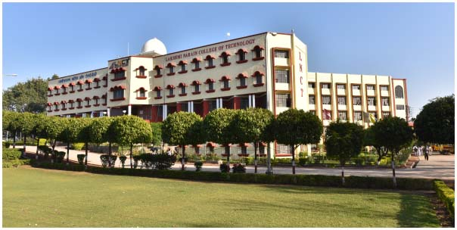

- Example of a figure caption. (figure caption)

